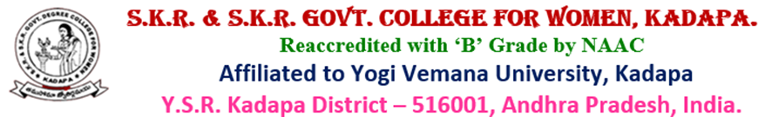
Best practices
2021-22

SKR & SKR Govt. College for Women (A), Kadapa has been implementing effective best practices to encourage the students and to extend their knowledge at both Institutional as well as field level. The college also believes that education will allow the students to bloom, blossom, giving them the right platform where they will work towards becoming an eminent and skilful persons to develop sustainability in the competitive society to become success.

Ecofriendly Ganesh festival celebration

Women’s day celebrations
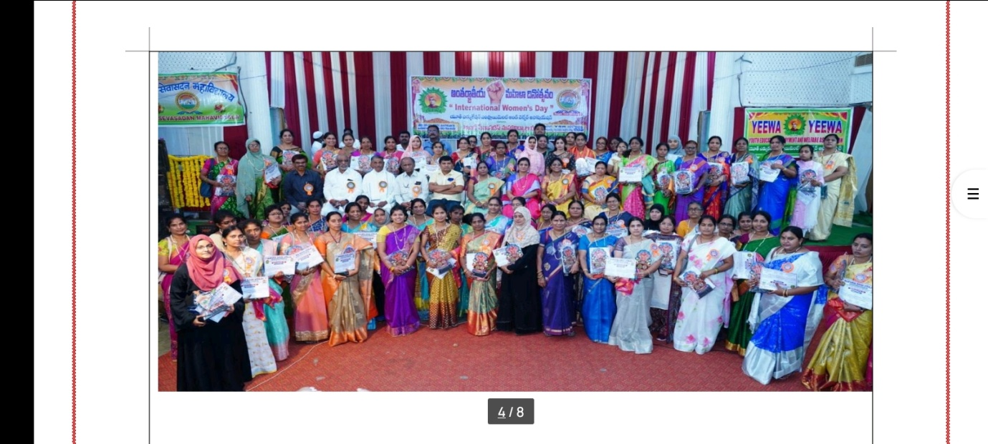
National Girl child day celebrations
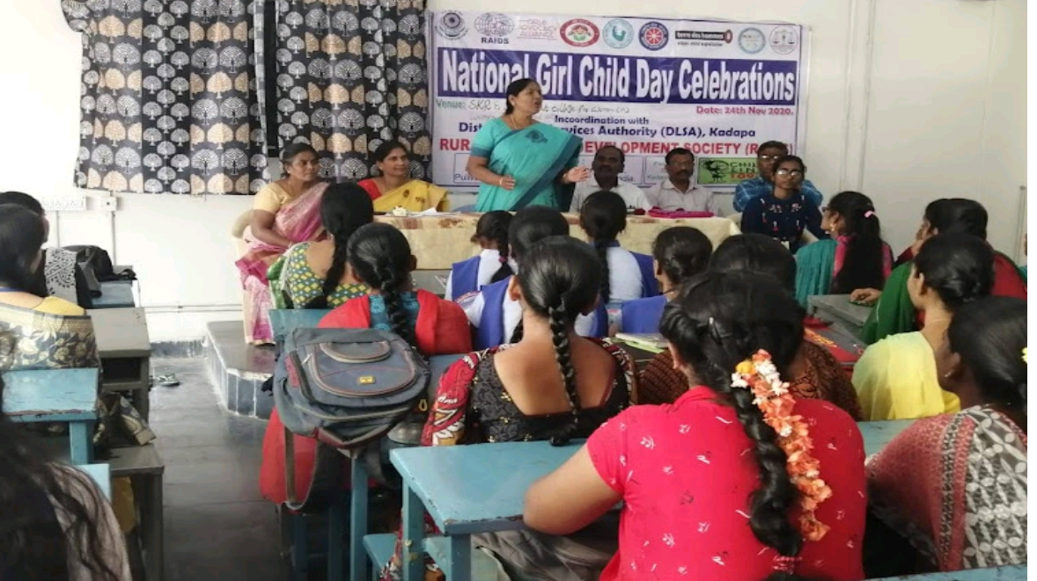
International Yoga day programme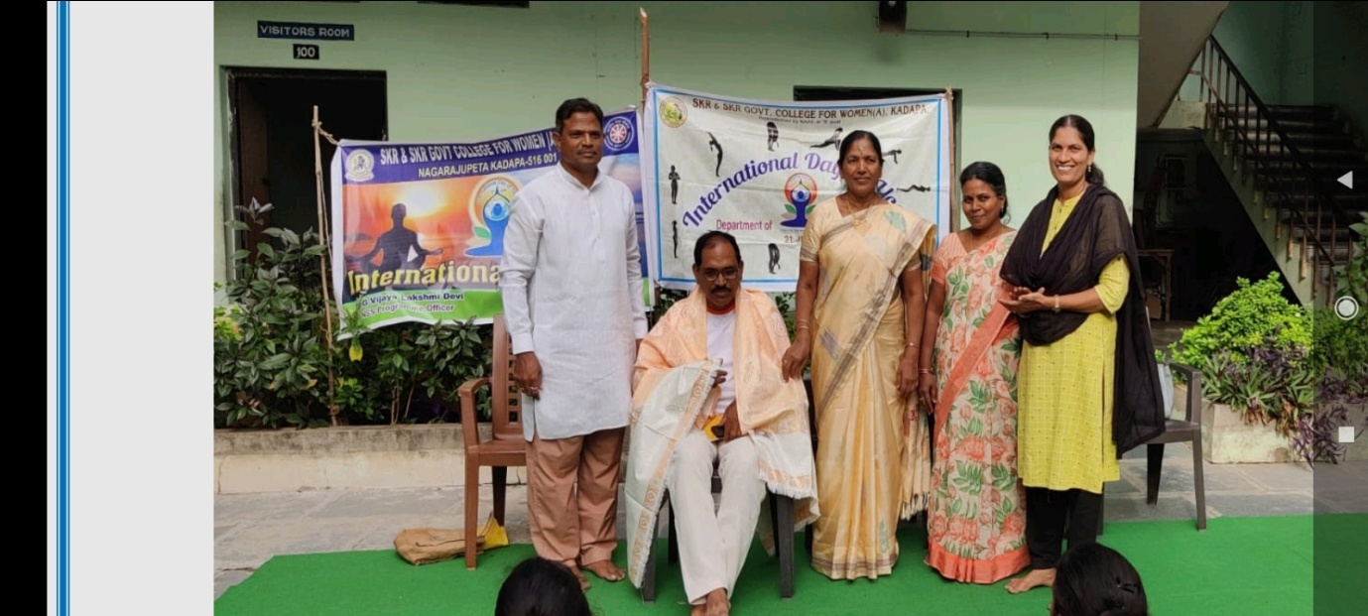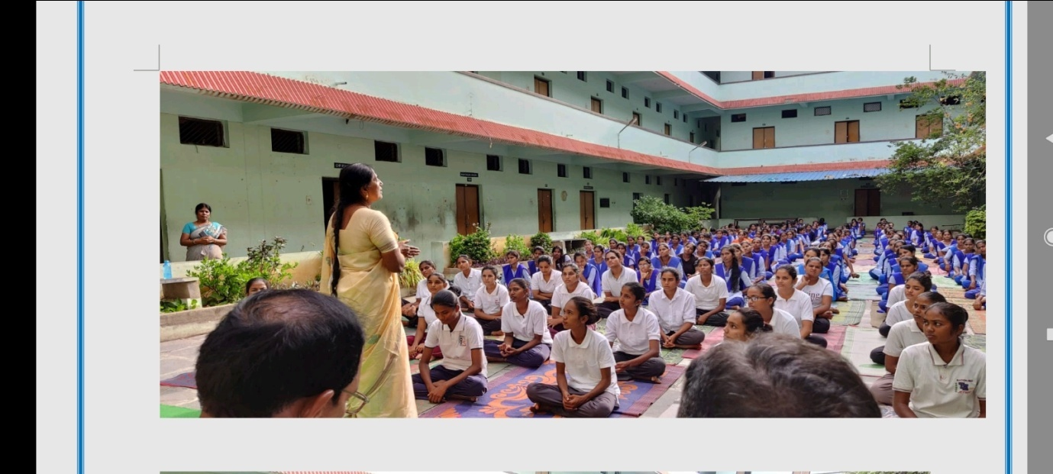
Aids Day awareness programme
Poster presentation on Cancer day
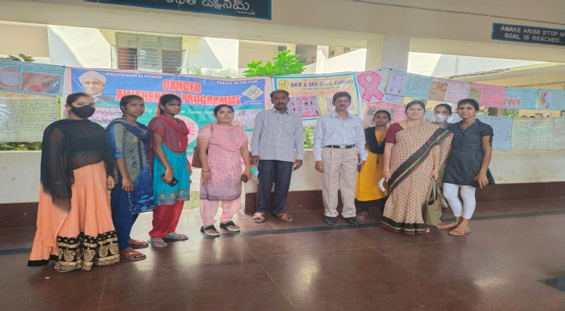

Blood Grouping program
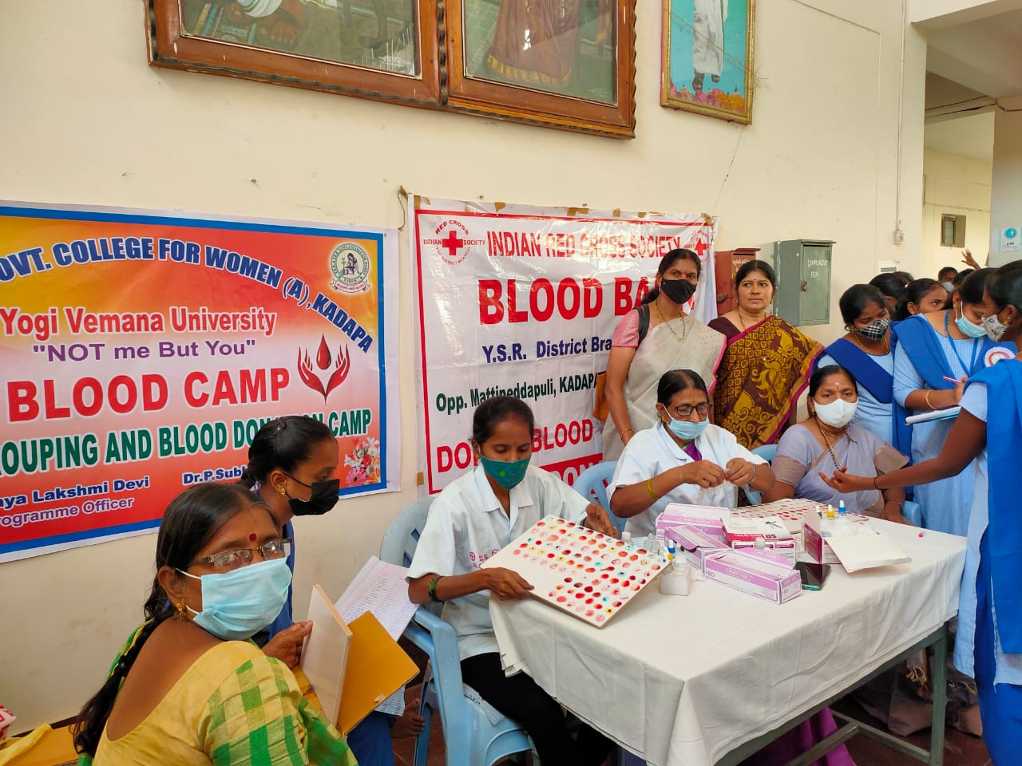

Student Counselling for various adjustmental problems.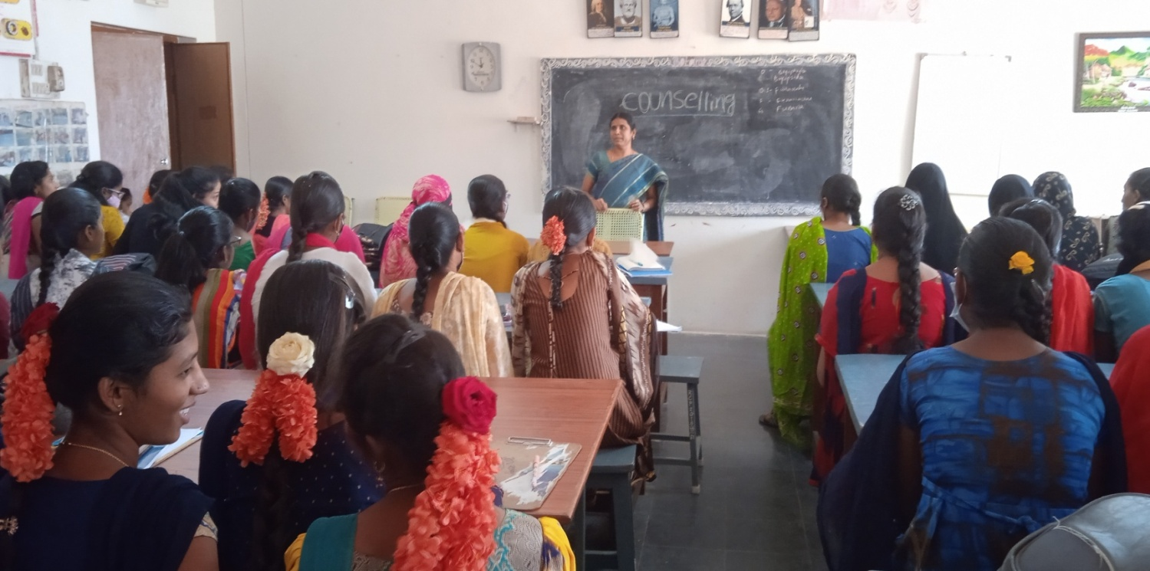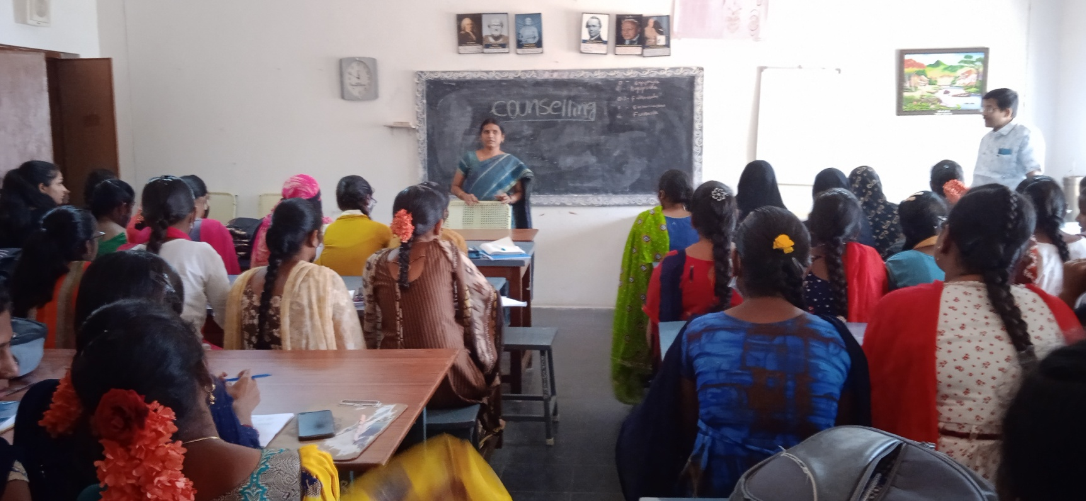

Plantation programme
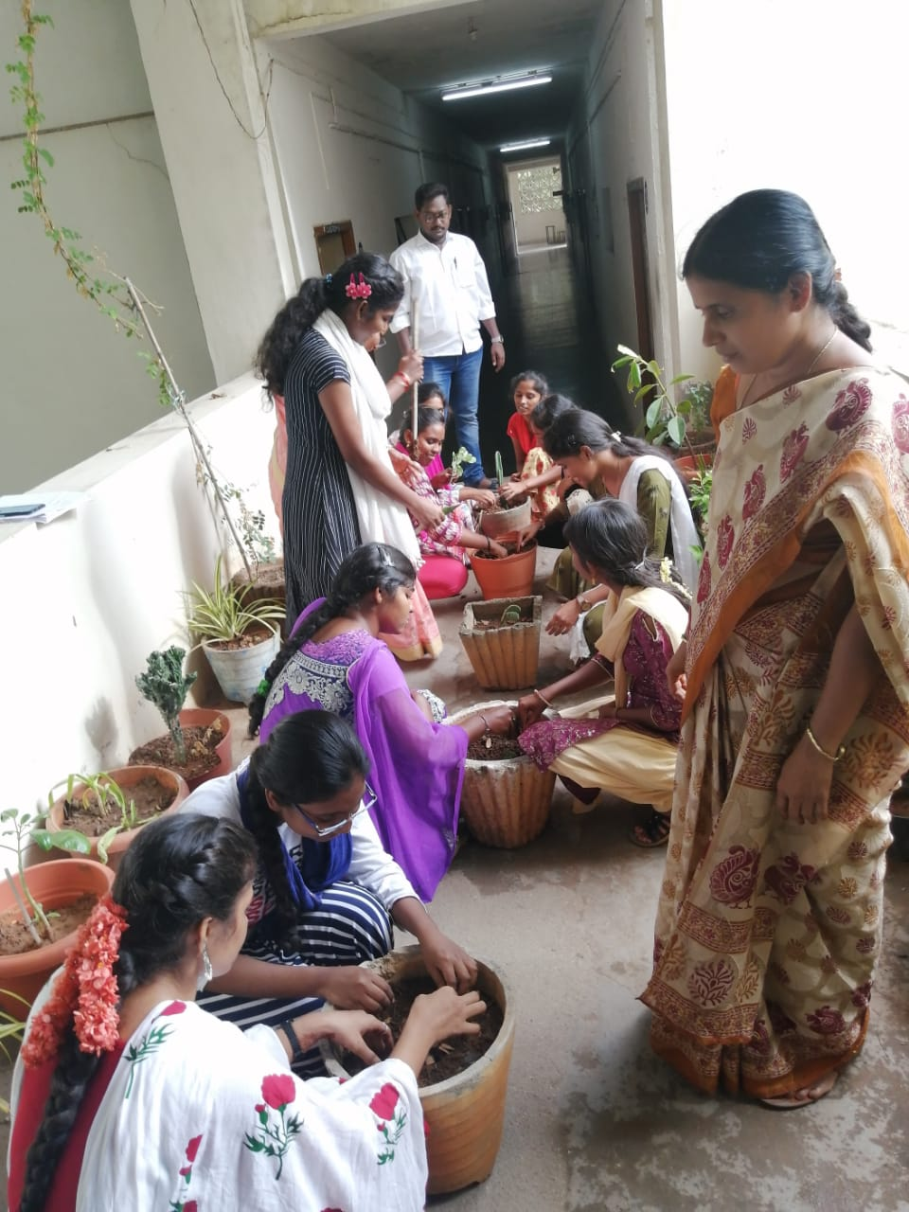

Clean & Green programme
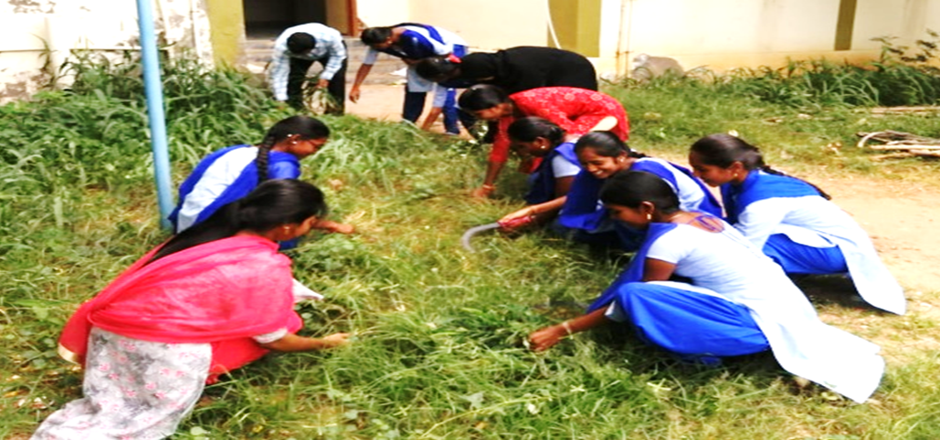
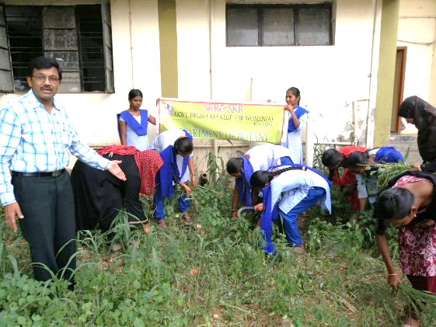

Field Visit to Regional Centre Tirupati
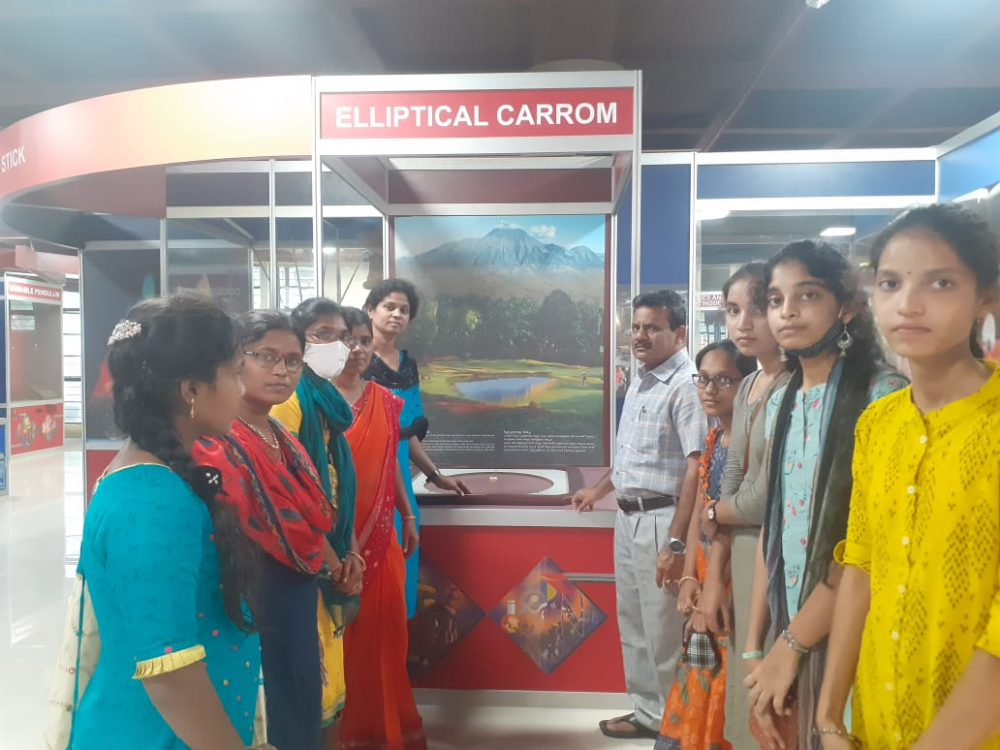

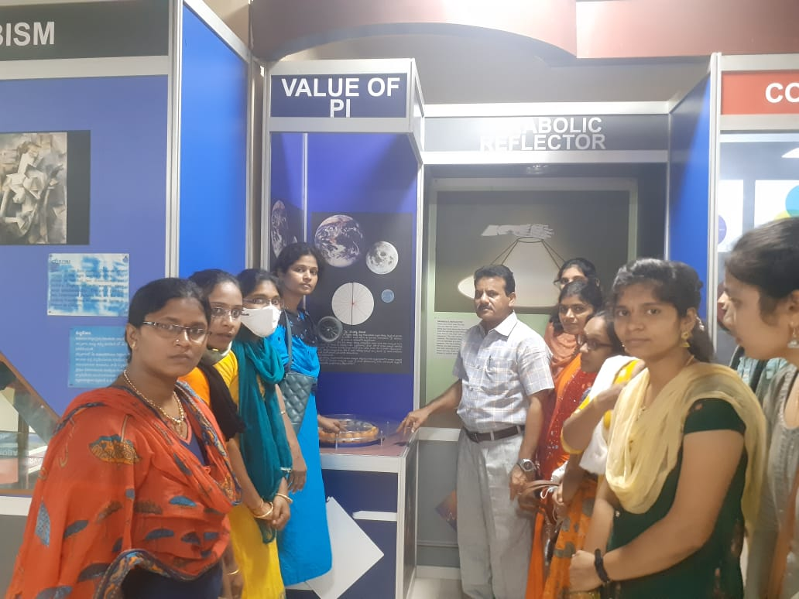
Field visit to YVU Botanical garden
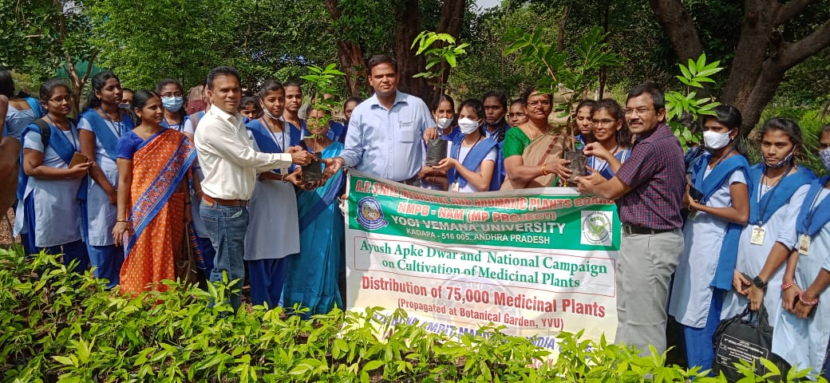
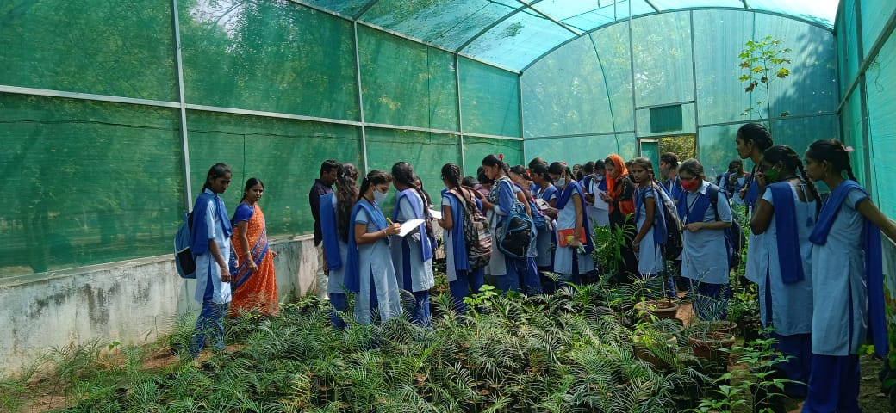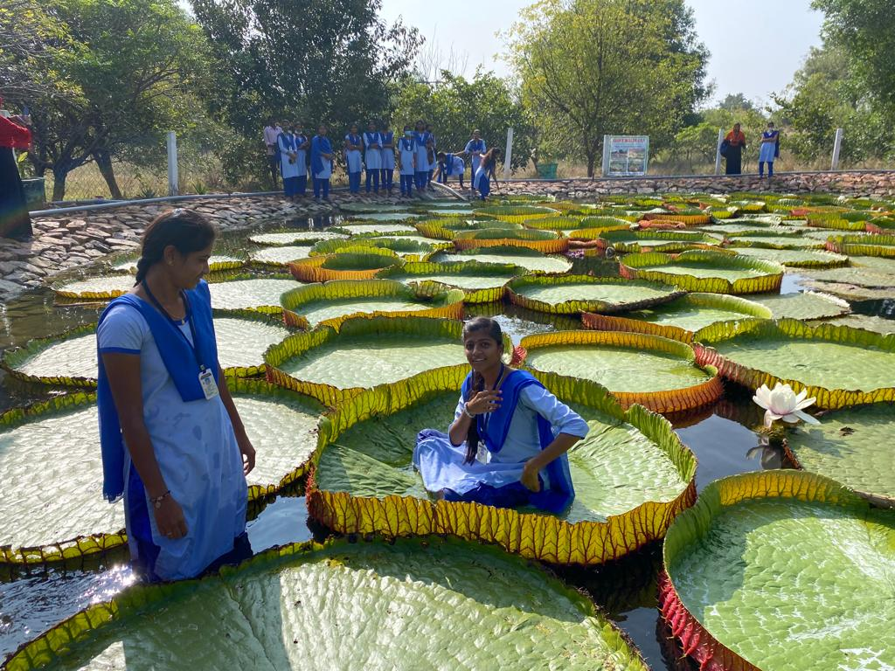

Guest lecture on Conservation of Endemic, Endangered & Rare species in Eastern Ghats

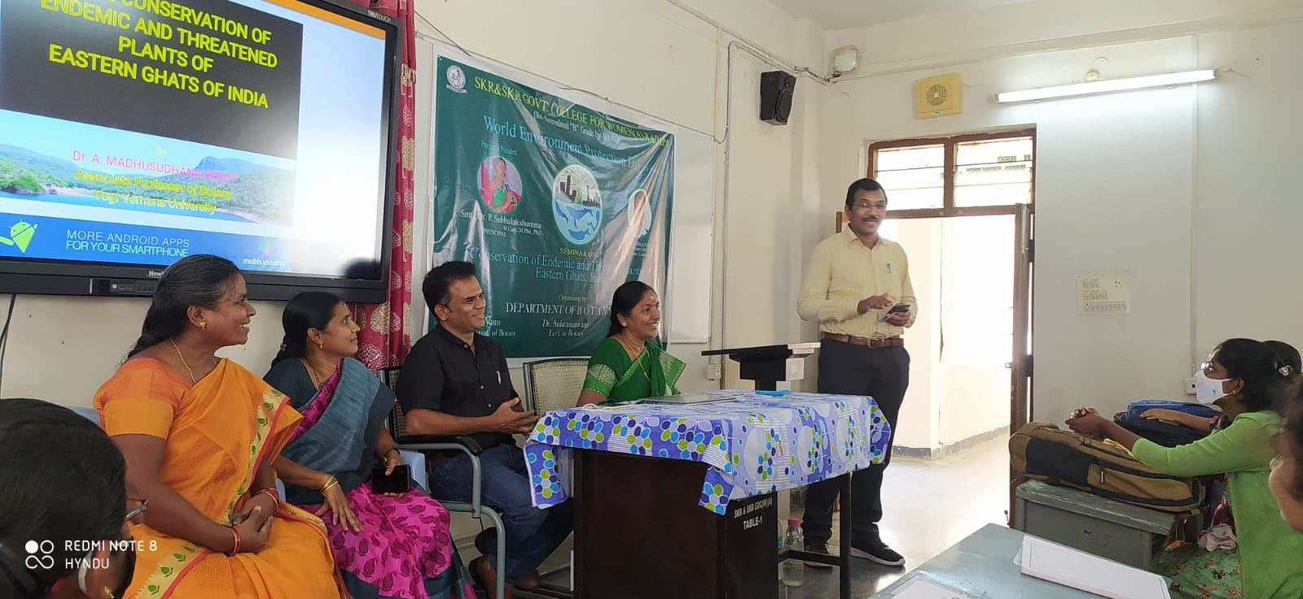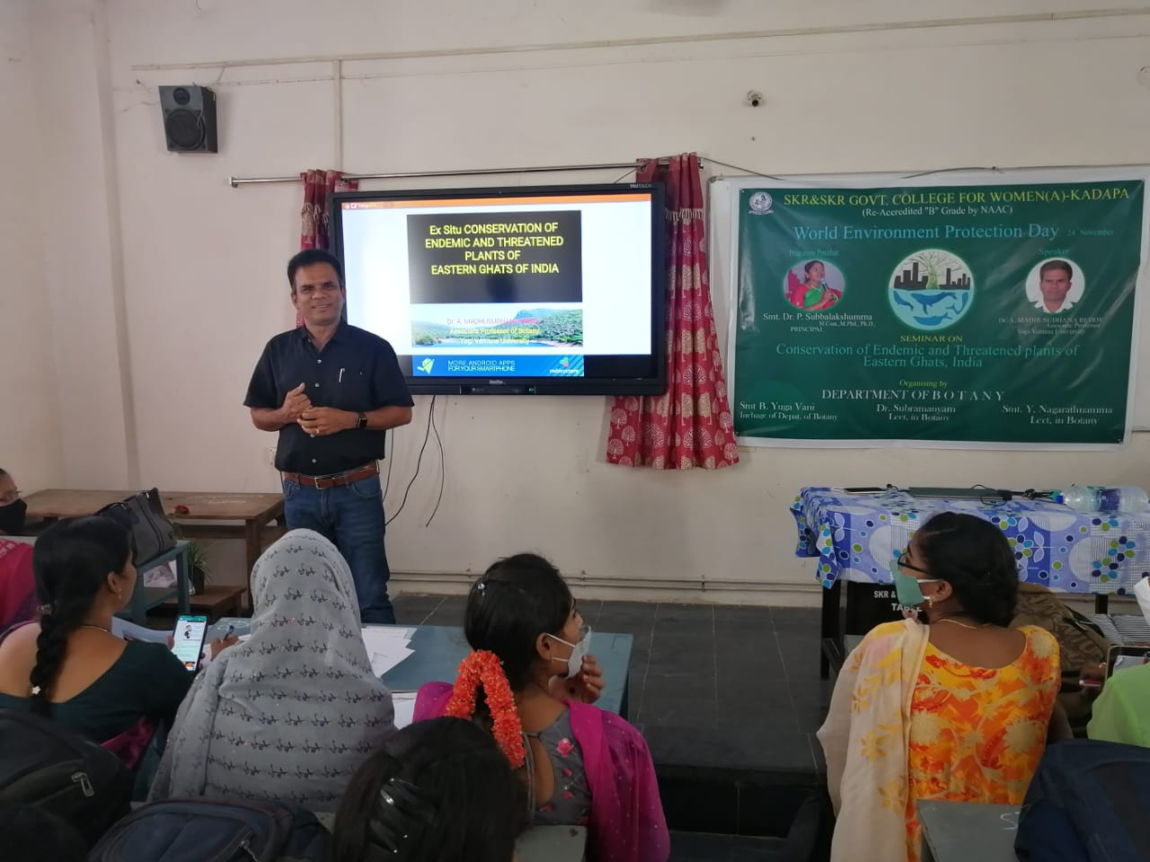

“Field Trip – Maithili Life Sciences Pvt Limited
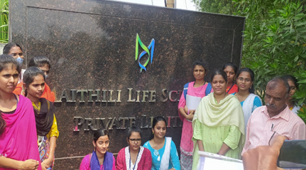
JAYANTHI “Harmful effects of cigarette and other tobacco products”
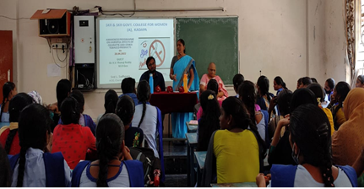

“Awareness program on Say No to Drugs”
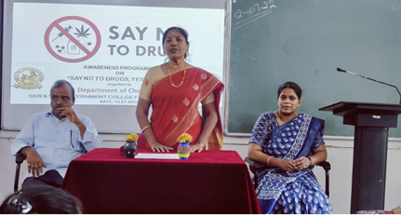

NDHI J
“International Ozone Day”

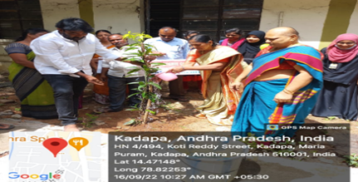
AYANTHI CE

DEPARTMENT OF MATHEMATICS
BEST PRACTICES-2021-22
Department of Mathematics sponsored Meritorious awards to the merit students on the occasion of National Mathematics Day celebrations on 22.12.2021.
Department of Mathematics organised National Mathematics Day celebrations on 22-12-2021. Principal Dr P.SubbaLakshumma, M.Com,,M.Phil.,Ph.D inaugurated the meeting by lighting the candle. The programme was started with prayer song. Principal explained in detail about the life history of SrinivasaRamanujan.
Dr S. Nagendra, Lecturer in Mathematics, Govt College for women(A), Kadapaattended as chief guest and delivered the contributions of SrinivasaRamanujan in Mathematics and beauty of Mathematics through PPT presentation.
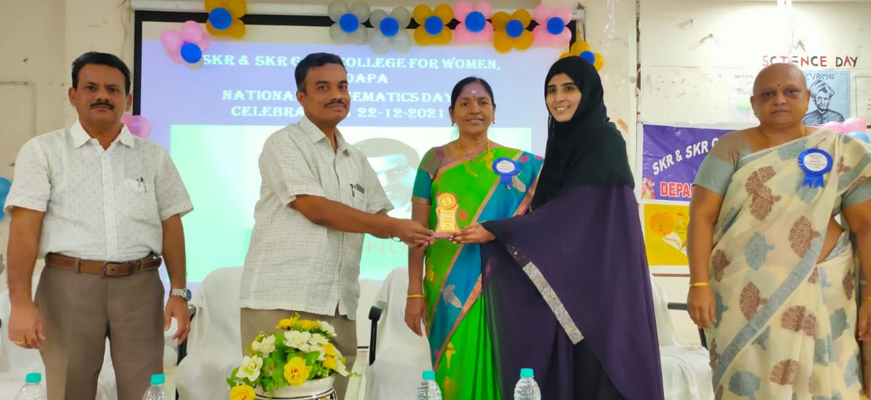

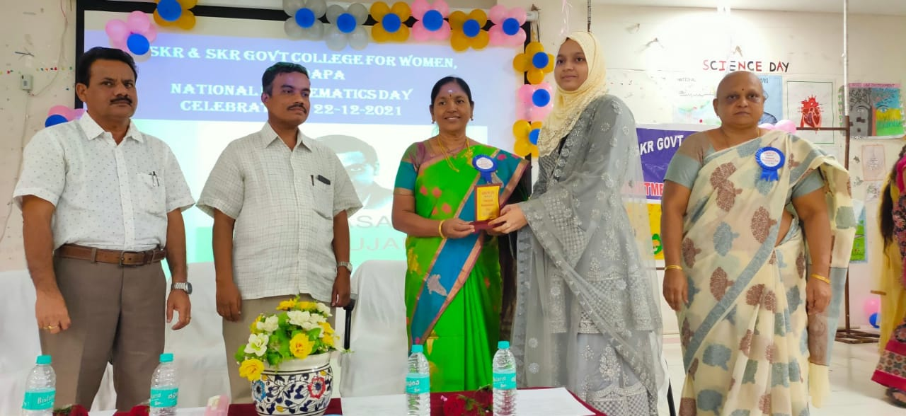
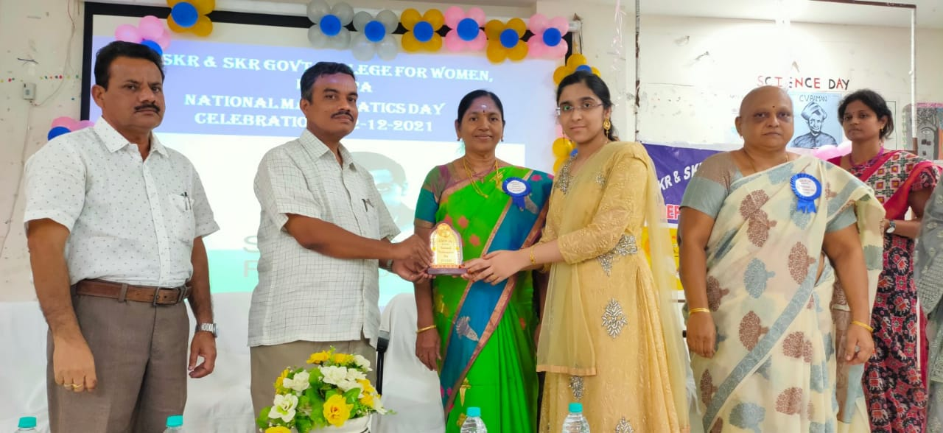
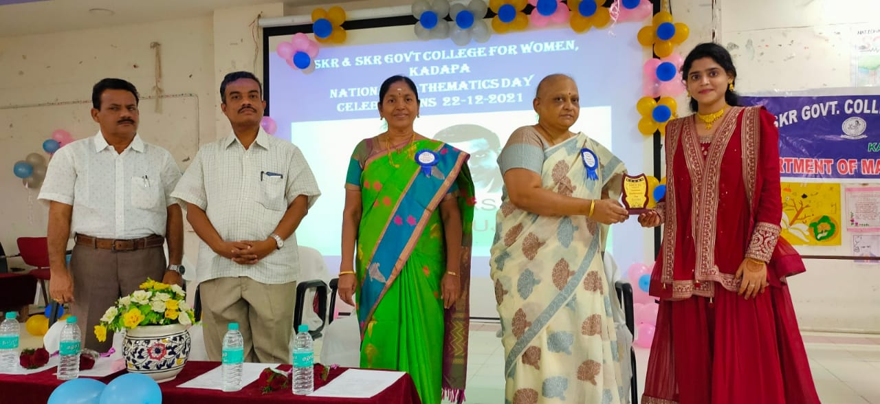

GUEST LECTURE ON LIMITS AND CONTINUITY BY APPALANAIDU FROM GDC MEN (A), KADAPA
ON 6th November 2021

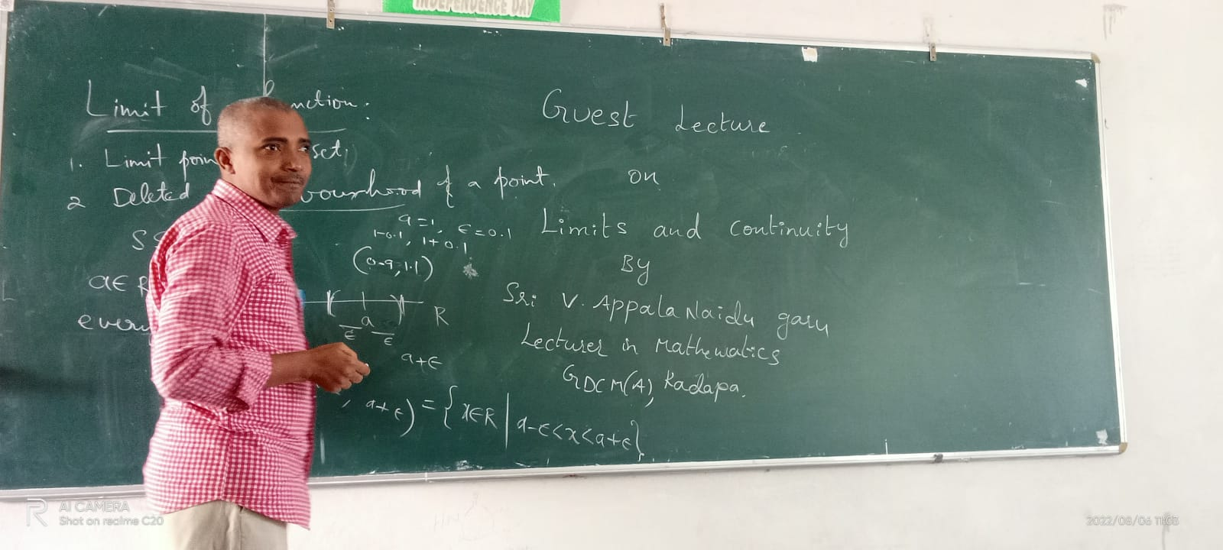

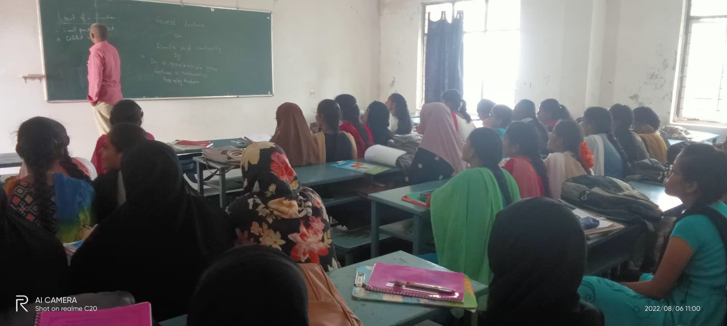

SWACHH BHARAT PROGRAMME
